# Exemplar: Using time intelligence to compare to previous year

## **Overview**

In the exercise *Using time intelligence to compare to previous year,* you were asked to create and format two measures using time intelligence DAX functions to help Adventure Works compare its sales.

Your tasks in this exercise were to:

* Download and connect to a dataset and review the model.
* Create two measures using DAX expressions.
* Create a matrix in Power BI to view the results of the measures.

This reading provides you with a step-by-step guide for completing these tasks. It also includes screenshots that you can compare against your work.

You can also review *Creating quick measures and creating custom measures with DAX*.

## **Step 1: Download and connect to the Adventure Works dataset.**

1. Download and save the Excel workbook Adventure Works Date.pbix from the exercise page on the Coursera platform.

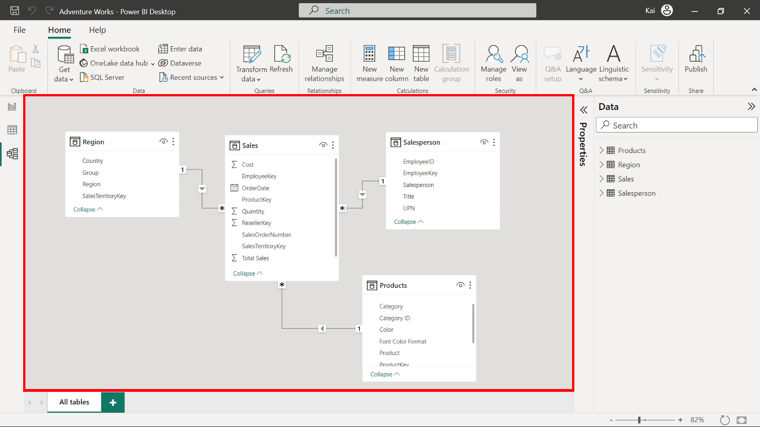

1. Load the data from the Excel Workbook in Power BI.
2. Select the Preview pane to open a preview of the table.

## **Step 2: Create the Revenue measure.**

1. To create the revenue measure within your data model, you need to use the Total Sales column from the Sales table and the Quantity column from the Sales table as follows:

1

* In this measure, the SUMX function computes the Total sales by multiplying the Unit price by the Quantity column of the Sales table.

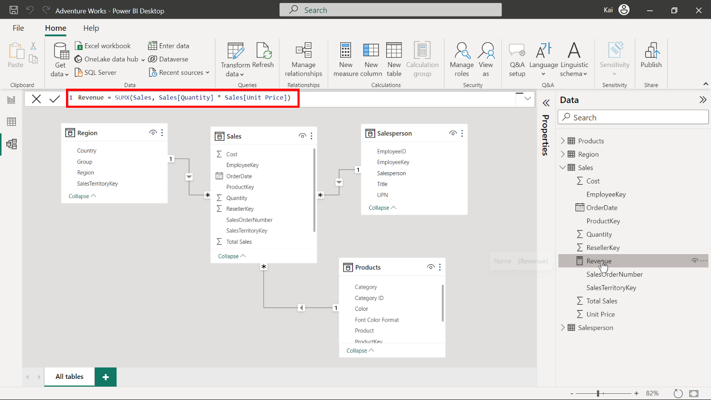

1. To format the measure, select the newly created measure from the Data pane. Then navigate to the Format group in the Measure tools tab of Power BI. Select Currency from the Format drop-down menu.

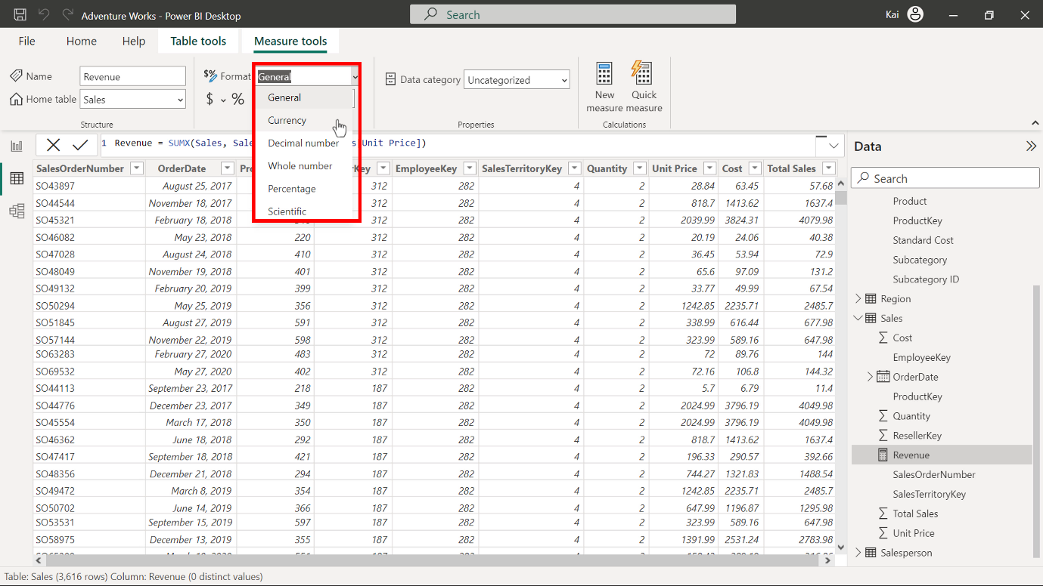

Enter 2 in the decimal places (currently Auto by default). This action formats the measure as a currency data type within two decimal places. This is best practice for visualization purposes.

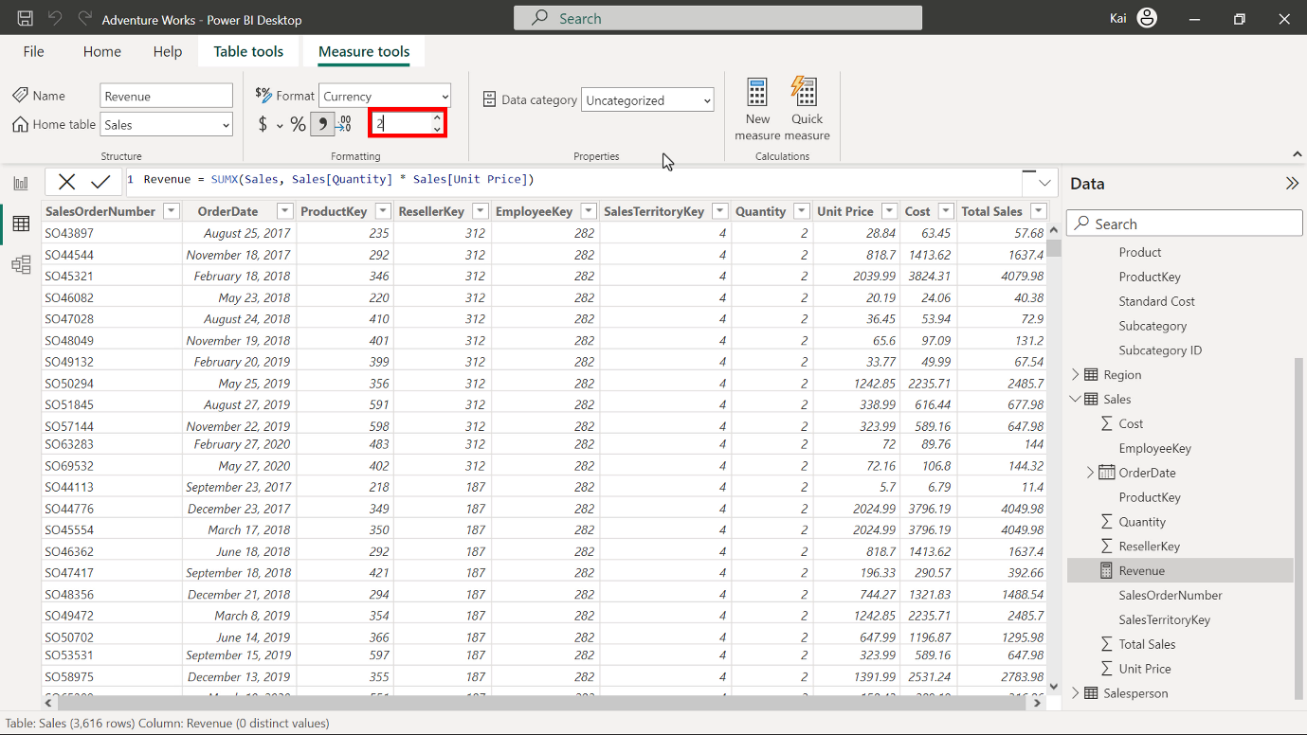

## **Step 3: Create the previous year’s and year-over-year revenue changes using DAX query.**

1. To create a new measure named RevenuePY, access the Data view. Under the Date pane, select the Sales table. Then select New measure from the Calculations group to expand the DAX formula bar. Add the following DAX expression to compute the RevenuePY measure.

1

2

3

4

5

* VAR is the variable defined for the previous year’s revenue.
* CALCULATE computes the total revenue using the SAMEPERIODLASTYEAR function, which uses the Date column from the Sales table as a parameter.
* Revenue in the square brackets is the previous measure you created.
* RETURN displays the value of the entire expression.

Once you execute the code, the Revenue PY measure appears in the Data pane under the Sales table.

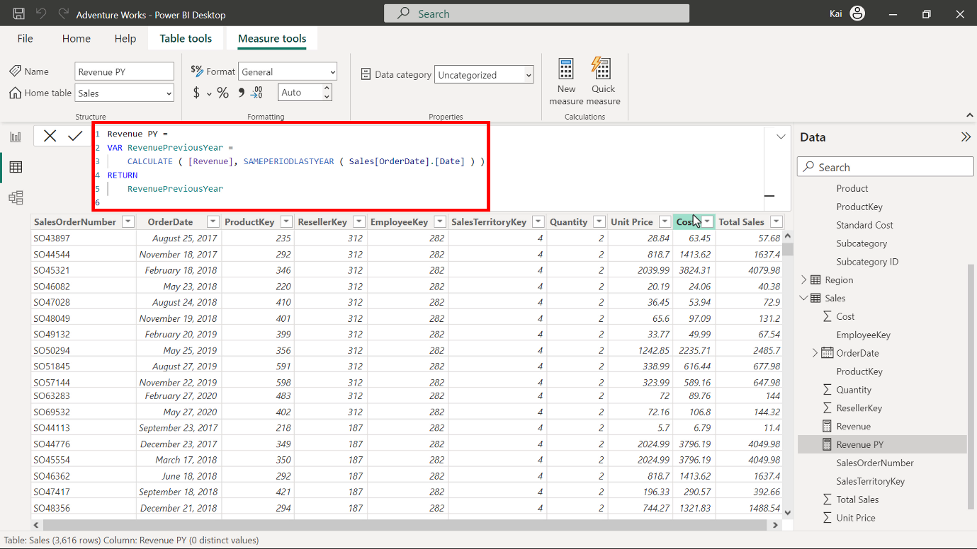

1. To format the new measure, select it from the data pane. Then navigate to the Formatting group in the Measure tools tab of Power BI. Select currency data type from the Format drop-down menu. Enter a value of 2 in the decimal place field (currently Auto by default). This action formats the measure as Currency data type within two decimal places and is good for visualization. You can view the results of the measure in the following diagram.

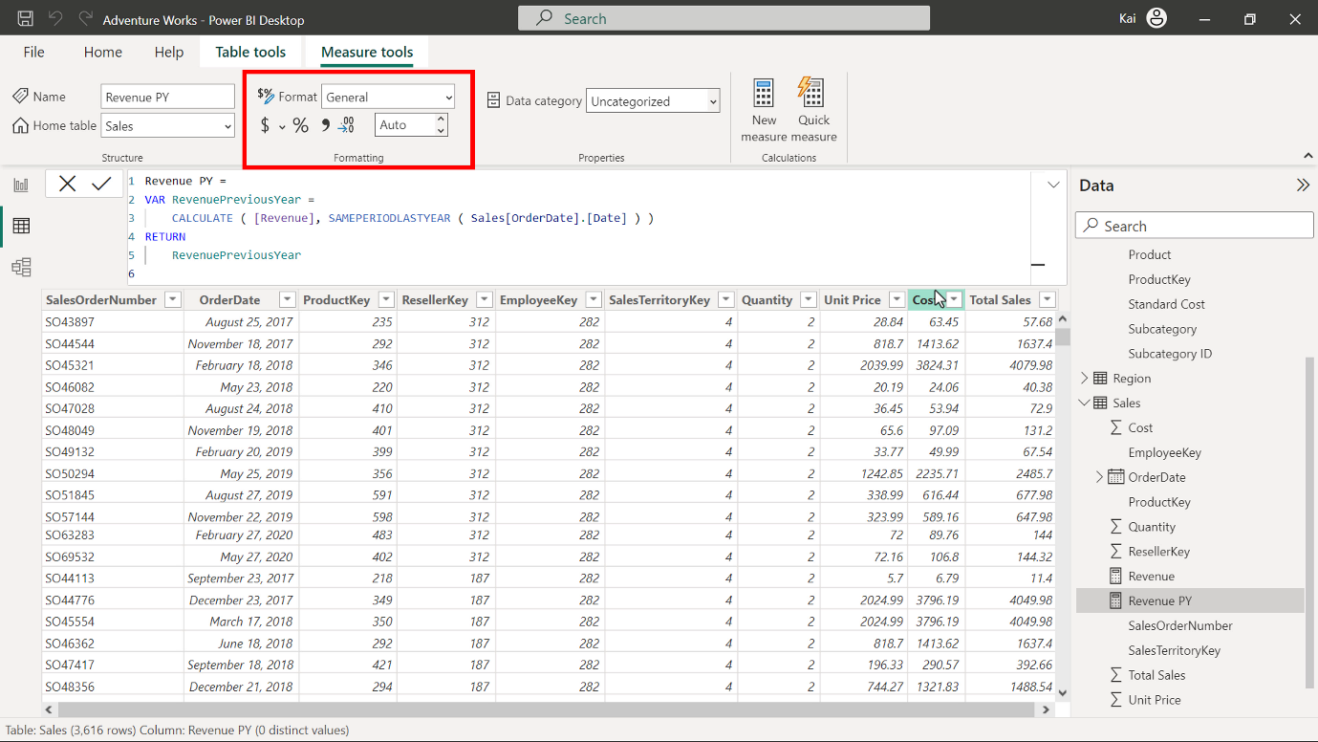

1. Repeat this process to create a new measure named Revenue YoY % using the following DAX code:

1

2

3

4

5

* In the above expression, in addition to the previous calculation, the DIVIDE function computes the change ratio of Sales by dividing the difference of the current year’s revenue by the previous year's revenue.

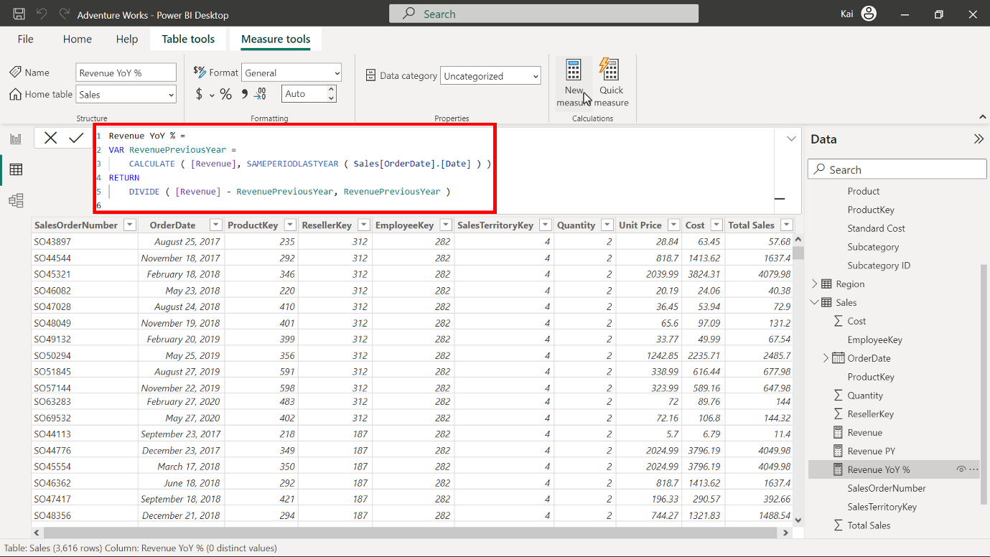

1. Repeat the formatting process from step 2. In this instance, remember to select Percentage instead of Currency.

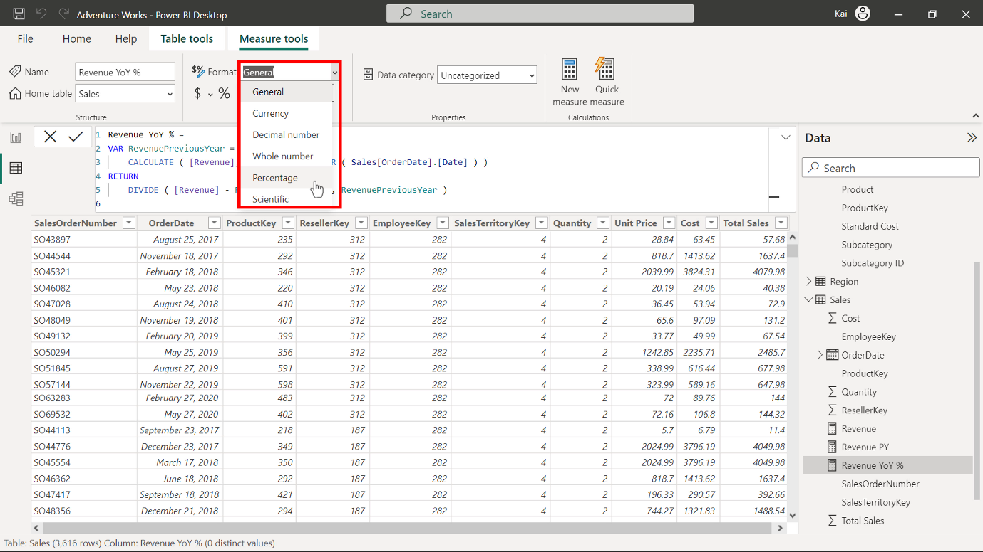

Enter a value of 2 in the decimal place field.

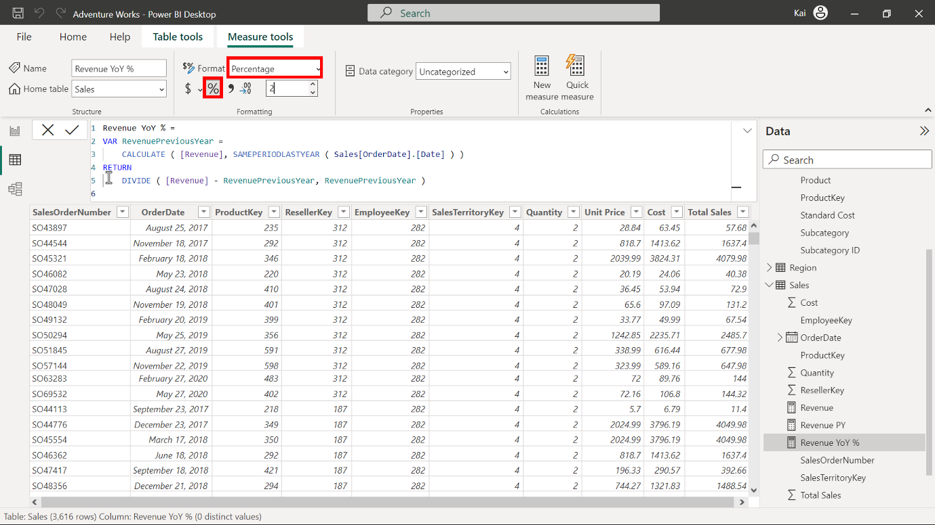

## **Step 4: Update the matrix in Power BI report view with the measure results.**

1. Navigate to the Report view of Power BI desktop.

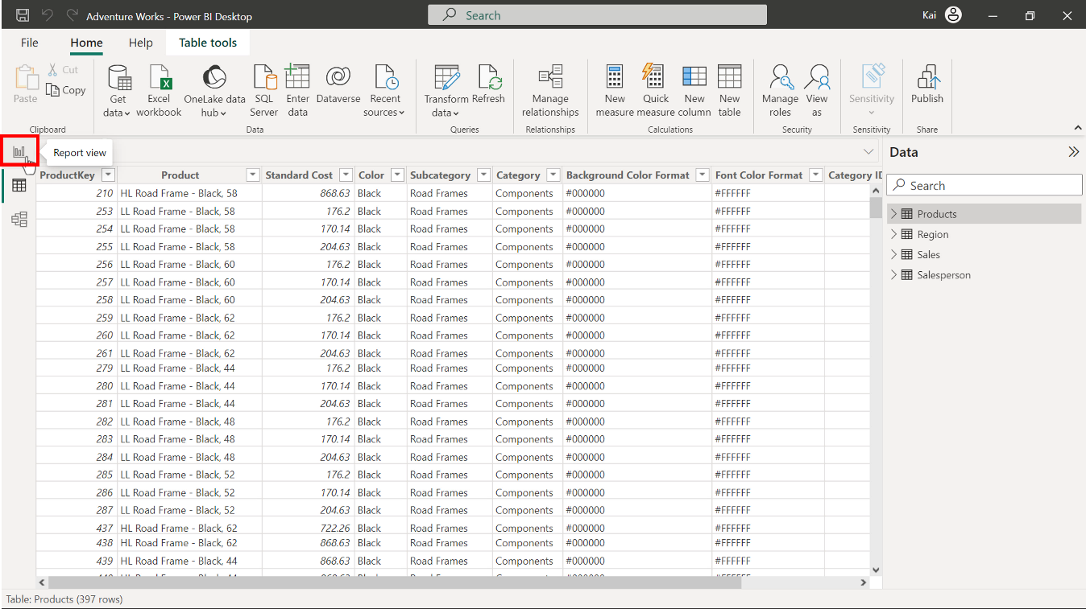

A premade matrix is present with a Year and Month column.

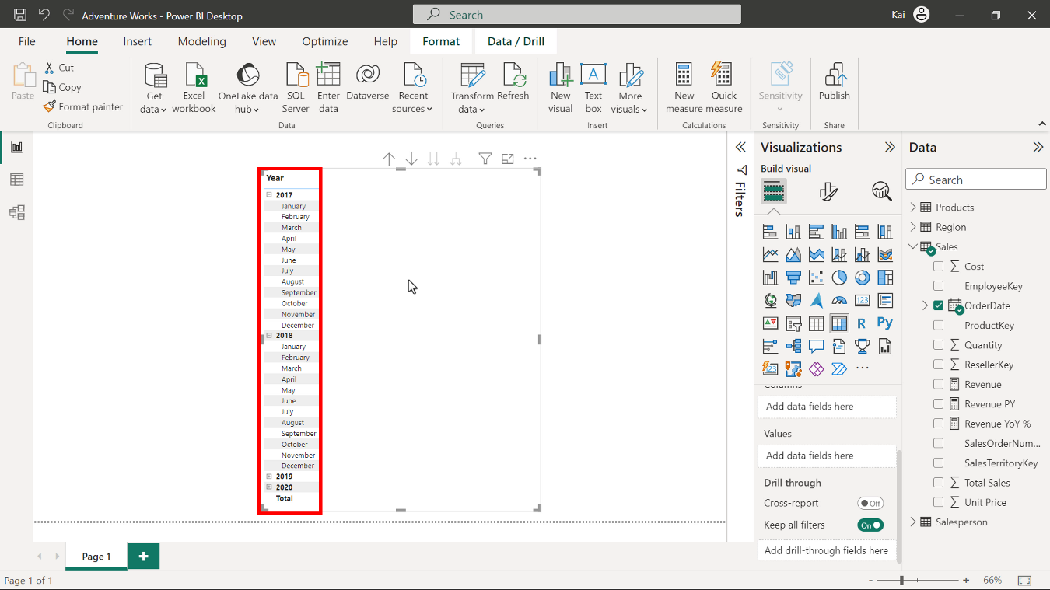

Bring the Revenue, Revenue PY and Revenue YoY % measures you have created to the matrix under the Values section.

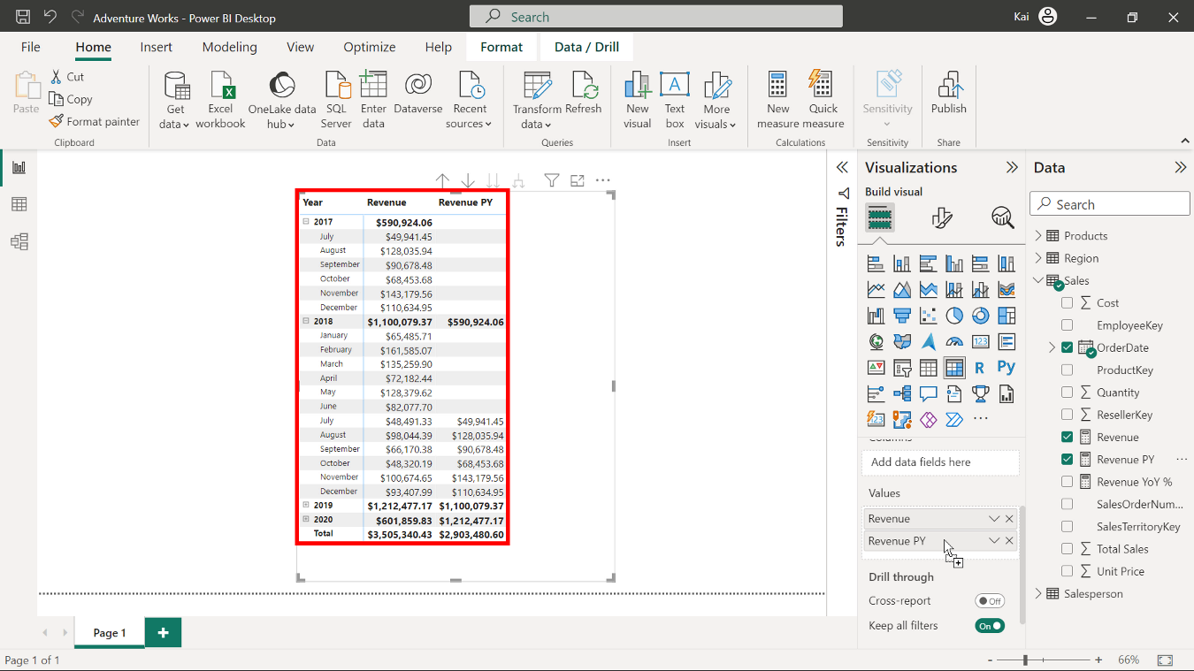

1. Note the values in all columns of the matrix. You can expand the Year by selecting the plus sign on the left side of the Year column in the matrix. A matrix view of the measure’s results is visible in the diagram below.

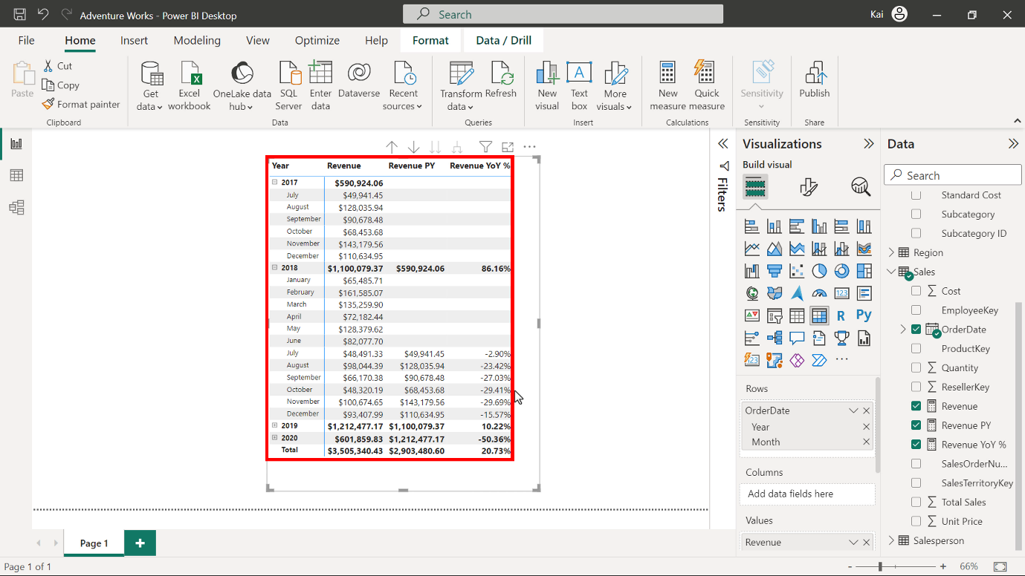

## **Step 5: Save the Power BI project.**

* To save your Power BI project, open the File menu, select Save As, and provide an appropriate name for the project along with a path to the folder on your computer.

## **Conclusion**

With these steps, you have successfully created measures to help Adventure Works analyze its data based on its analytical and business requirements and proven your capabilities with time intelligence functions.

Remember that when using DAX formulas, always ensure they are correctly formatted and that the column names match the actual column names in your data.